AVP Wales/Cymru is a branch of the charity AVP Britain. We run low cost workshops to help people who have experiences of anger or violence, whether as perpetrator or victim or both, to help them to learn new skills and build healthier relationships.

On a course we aim to develop within a group of people the trust and confidence to share experiences, feelings and concerns, and to explore different ways of handling situations in order to manage and resolve conflict in constructive ways.

During our workshops we cover the following skills: self-esteem & affirmation, understanding what violence is, listening skills, community, cooperation, communicating without blaming, understanding anger, behaviour types and problem solving.

We provide workshops in the community, in prisons and via partnership projects with other organisations. We also promote AVP Britain’s online distance learning course, ‘Facing up to Conflict’.

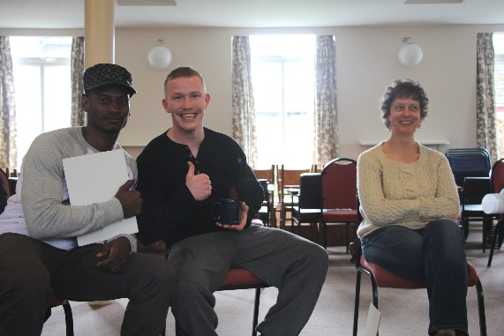

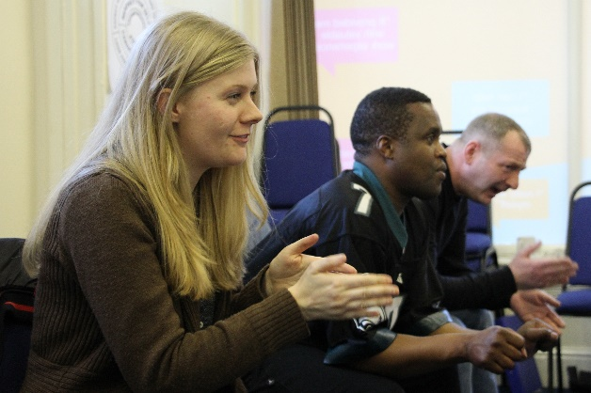
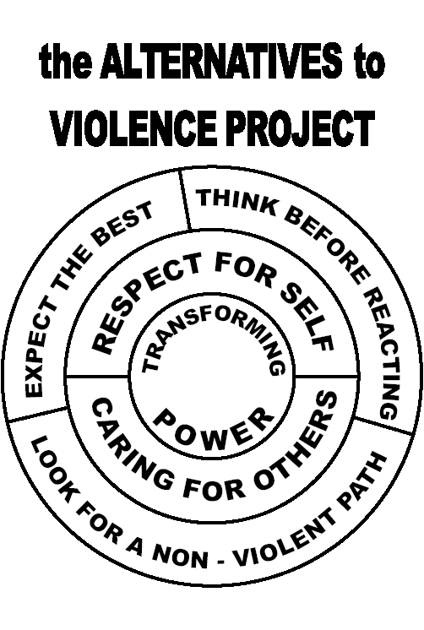

For more information contact us at info@avpwales.org.uk

Or visit our websites at:
www.avpwales.org.uk
www.avpbritain.org.uk

