Registered Charity Number 1173698

What do men do in a mens shed? They:
- Undertake some activity in the company of others
- Spend time with like-minded men with whom they can work and talk
- Participate in some joint endeavour
- Find friendship and companionship
- Provide help and support to themselves and others
- Make use of the workshop or other facilities
- Learn new skills or revive old ones
- Make a contribution to the community
Opening Times:
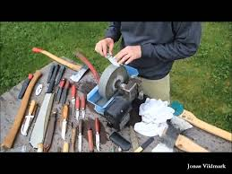

Mondays 10am to 2pm
Wednesdays 10am to 2pm

KNIFE & GARDEN TOOL SHARPENING SERVICE
Address: Teme Mill, Station Yard 07925357782
Knighton, Powys, LD7 1DT
(On the bend before the station)
Website: www.mensshed.uk knightonmensshed

Or

With grateful help from the following organisations:

