Welcome to St Jerome’s Church

Introduction
By virtue of its name “Llangwm” (Holy place in the valley), this village has had a church since the 7th or 8th century. It was rebuilt and enlarged into a conventional cruciform shape in 1185 by Sir Adan de la Roche whose family lived here from it is believed, about 1120. The church was further enlarged in 1350 with the building of the De la Roche family chapel. You will learn more about the De la Roche family when you view the Tapestry in the chapel having downloaded the “Talking Tapestry of Langum” App. But before you head there, why not take a wander around the rest of the church.
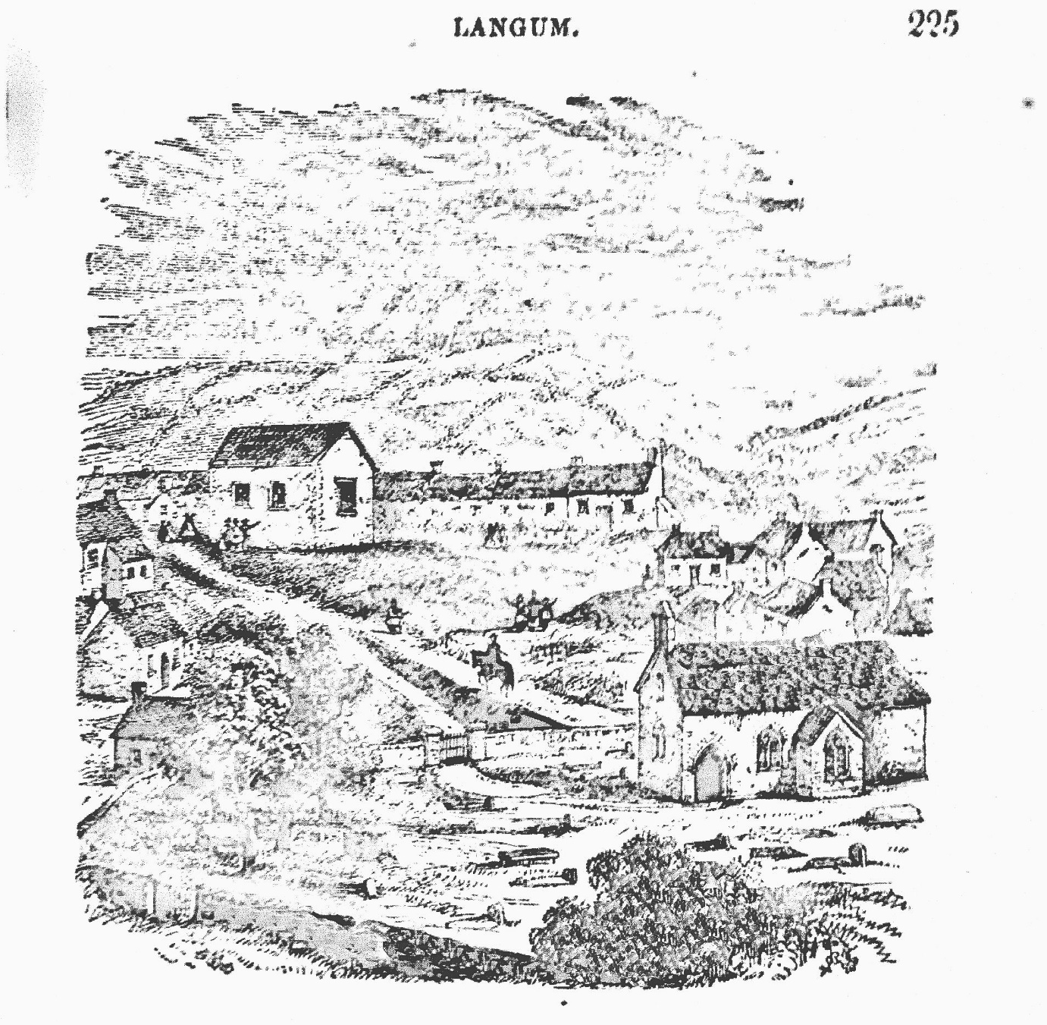
Ext Church - 1865

The Font
At the rear of the church, right beside the entrance door you will find the Norman Font. This is the oldest artefact in the church and believed to have been placed here by Sir Adam de la Roche himself. It is also said that his children were the first to be christened in it.
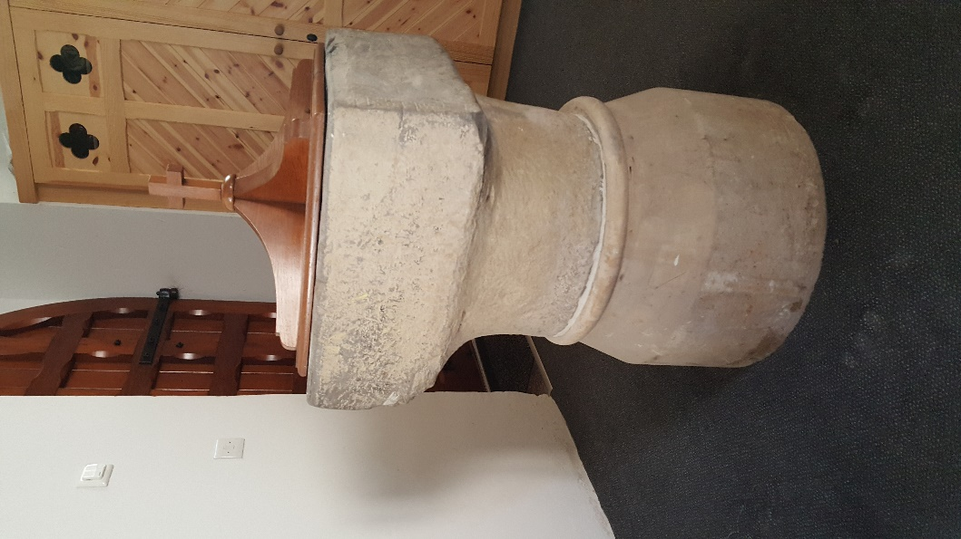
Font – donated by Sir Adam de la Roche in 1215

The Western end of the Nave
Now dominated by a large window that catches the light from a setting sun during evensong, this end of the church had a gallery built in the late 16th century to accommodate more people after the reformation, a time when it was compulsory to attend church on a Sunday. Indeed the De la Roche chapel was also fitted out with pews, the family having long since left the Llangwm community.
Halfway down the nave and on both the north and south sides you will see the two main windows. Prior to 1879 when the church underwent a significant restoration, both those windows would have been entrances to the church and if you look from the outside, you can still see the outline of the medieval doorways.

The Rood Loft - Long since removed, probably at the time of the Reformation, St Jerome’s had a rood loft facing into the nave over and above a smaller archway that the one there today. The only evidence that there was a Rood Loft are the stones jutting out from the archway above the pulpit. Those stones would have supported a stairway up to the loft where choristers would have sung.

The Chancel
Up the steps into the Chancel and this is what would have been the early pre Norman or Welsh church. The Welsh Church from the 7th century up to the Norman invasion, practised the catholic Mass and priests used to live together in small groups in what were called Priest’s Houses and it is believed that St Jerome’s and its current churchyard, which then stretched right down to the river was one of those. What is now the chancel would have been their chapel. Dormitory accommodation would have been nearby as well as a kitchen and gardens to grow food. These priests would travel out each day to hold a mass in other churches of the Rhos area.
If you go outside the church, you can still just see the outline of a doorway in the stone work on the south side, as well as a Leper’s window. Lepers would not have been allowed inside the church for fear of infection, but they would be allowed to hear mass through that window.
In 1573, on the orders of Elizabeth 1st ordered that every church in her kingdom should receive a specially made silver chalice to be used at Holy Communion services. Many got melted down at the time of the Civil War to help pay for arms for the royalist army, but thanks to the then minister, one Peregrine Phillips who supported the Parliamentary cause, the chalice was preserved and it is still used for special services such as Christmas and Easter. Because of its rarity value it cannot go on display.
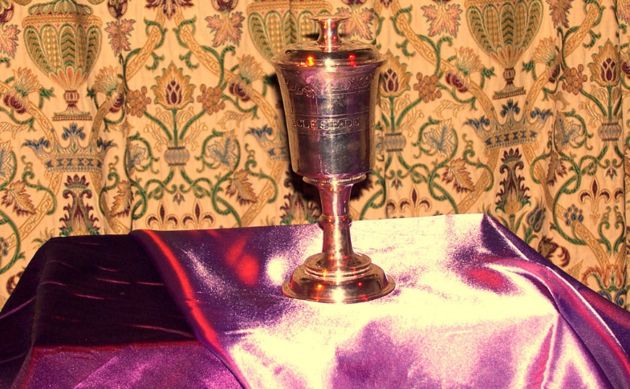
Elizabethan Chalice

The De la Roche Chapel
Before 1350, this chapel to the left of the Nave would have been the same size as the vestry located on the south side of the Nave. But on the death of the Lord of the Manor, Robert de la Roche in 1347, his son and heir John at 8 years old and being too young to take over the estate was taken into the care of his aunt Isobel de Bermingham. However the family decided to build a family chapel. However the Black Death intervened, arriving in Pembrokeshire in 1348 and no construction could be completed until 1350. Even then, the family had to call on the peasants, taking them from their duties in the fields to build it. As such it has no foundations and the stone work is not that good. But let’s take a quick tour.
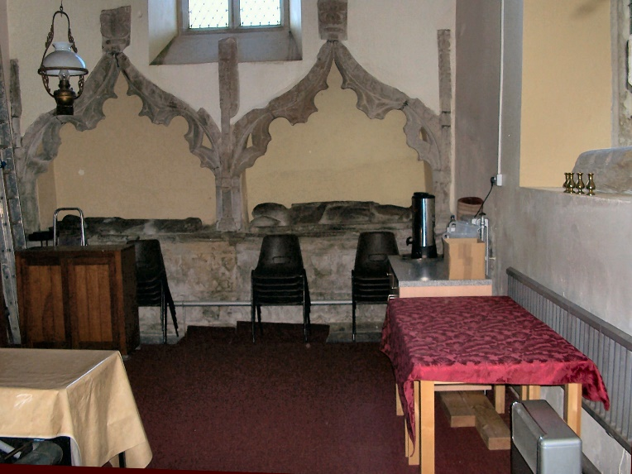
De la Roche Chapel

The Hagioscope.
The first thing you come across as you enter the chapel is the “Squint” or “Hagioscope”. In medieval times, noble families would have their own family priest. So rather than attend the main Mass in the Nave among the peasants, the family would have their mass in their own chapel. There would be the local priest at the high altar and the family priest would use the Hagioscope in order to keep his Mass synchronised with what was happening in the body of the church.
The Holy Water Niche
Next to the Squint is the Holy Water Niche. Prior to the Reformation and the establishment of the Protestant Church of England & Wales, St Jerome’s like all the other churches in the country was Roman Catholic, that being the only form of Christian worship practised in Britain then. Inside the niche would have been a bowl of water, water from the River Jordan having also been blessed by the priest. Upon entering the faithful would dip their forefinger into the Holy Water and make the mark of the cross on their faces before proceeding to the altar to pray.
The Norman Window
As it is called, is the oldest window in the church and dates back to 1350, the time the chapel was built. It faces east and a small altar would have been positioned directly below it.
The Grave cover
Mounted on the wall just beside the effigy of a knight is a 9th century grave cover and the faint outline of a Celtic Cross can still be seen carved onto it. This, and part of another mounted into the wall beside the Vestry door, were both dated by CADW and their existence proves there was a church on this site long before the arrival of the Normans.
The Effigies
At the north end of the chapel you will find two effigies laid beneath two very ornately carved archways. They are Lady Margaret de la Roche and her grandson Robert de la Roche. These were placed in the chapel after it was built. Lady Margaret (1254 – 1315) whose effigy would have been carved within 18 months of her death was originally placed up beside the high altar. It is said that her bones were kept in a lead casket and placed beneath her effigy. Then after Sir Robert de la Roche (1315 – 1347) died, the family made the decision to build a chapel, Lady Margaret’s effigy was brought into the chapel and laid to rest in the left hand archway, while Sir Robert’s effigy was laid in the right hand effigy.
You will also notice that there are shields all along the effigy plinth and on the Holy water Niche… there’s even one mounted on the archway entrance to the chapel. Originally all this stonework would have been brightly painted, the effigies looking lifelike and the shields would have borne the coats of arms of the families that had married men of the De la Roche family and those families that De la Roche daughters would have married into. Dr Rhianydd Biebrach, a specialist in reading effigies made a full study of the effigies and family tree and concluded that the chapel was to be a celebration of the family. The shields and grandmother and grandson displayed together suggests that the family were making a statement, “We are an important family in Pembrokeshire, we’ve been here for 200 years and we’ll be here for a lot longer”. As it happens, the son John did return to Llangwm in the late 1350s to reclaim his inheritance, but the family didn’t stay long in Llangwm and by 1400 the lands had been shared out among relatives still in the county and the De la Roche manor house fell into ruin. It was well into the Tudor period before a new manor house was built and another important family settled in Llangwm.
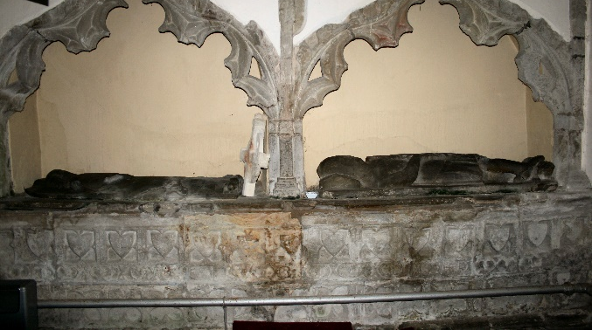
The Effigies before Restoration
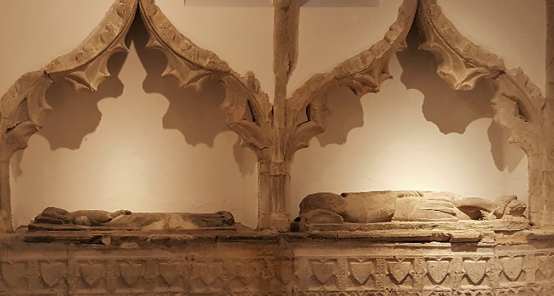
The Effigies after Restoration

The Talking Tapestry.
We finally come to the six panel Talking Tapestry of Llangwm which tells the story of the Flemish settlement of Pembrokeshire after 1105, the arrival of the De la Roche family and significant parts of the story of medieval Llangwm.
To get the full value from the tapestry, you need a smart phone, an android tablet or an I-pad.
1. You need to connect your device to the church Wi-Fi. You need to find St, Jerome’s Church in your Wi-Fi choices. Select it and when prompted enter the password jerome1185
2. Go to the heritage Llangwm Website – www,heritagellangwm.org.uk
3. On the Home Page select the Video with the language of your choice, English, Welsh or Flemish. This will take you to a half hour presentation by Mabel, wife of Hugh The Fleming, which tells you all about the story of the Flemish settlement in South Pembrokeshire and that of the De la Roche Family who were granted the lands

Archaeological Discoveries.
In the cabinet below the Talking Tapestry, you will find some of the archaeological discoveries found at the site of the Old Manor house in 2016. There are also reproductions of medieval documents referring to the Flemish settlements. One is a copy of the second most valuable document after the Doomsday Book held at the National Archives. This is the Pipe Roll, or Royal Accounts for Pembrokeshire 1130. On the section visible you will see mention of Godebertus Flandrensis, the man we know as Godebert The Fleming, the father of the De la Roche dynasty.

This ends the tour of St Jerome’s and we hope you enjoyed it, but we haven’t finished. Read on to learn about legends and stories relating to Llangwm, St. Jerome’s and the De la Roche family.

The Legend of Adam de la Roche.
There is a legend , in fact there are two legends associated with Adam de la Roche. The first is that he was cursed by an old woman after he ordered that her cottage was knocked down; there again that legend also tells us that he was told by a sooth-sayer that he would die from the bite of a viper. In fact the so called curse said exactly the same thing. Adam was afraid of vipers and there were many around in Pembrokeshire in the 12th century. The legend goes on to tell is that Adam retired to the upper rooms at Roch Castle. Then one day, he summoned a servant to bring more firewood. The servant duly obliged and placed a pile of wood beside the fire. Adam reached into the pile to throw some wood onto the fire, but unbeknown to him, there was a viper resting on one of the pieces of wood and as Adam lifted it, the serpent struck out and bit him. The poison killed him a few days later.
The second legend rather carries on the story. Adam was given a Requiem Mass in the castle chapel and then buried in the small graveyard in the castle grounds. However the next morning, his shrouded corpse was found outside the entrance to St Jerome’s Church in Llangwm. It was taken back to Roch and reburied. Yet, the next morning it had returned to Llangwm’s church. Once again a horse and cart took Adam’s body back to Roch. But this time the servants decided to lie in wait to see what happened to his body. Then at the dead of night, it is said that ghosts and ghouls rose from the graves that were already buried there and they bore his body back to St Jerome’s. This time it was decided to bury him along with his ancestors below the high altar in the church.
There is always a grain of truth associated with every legend and it’s reasonable to assume that perhaps Adam had requested to be buried along with his ancestors in Llangwm much to the chagrin of his servants and supporters at Roch Castle.
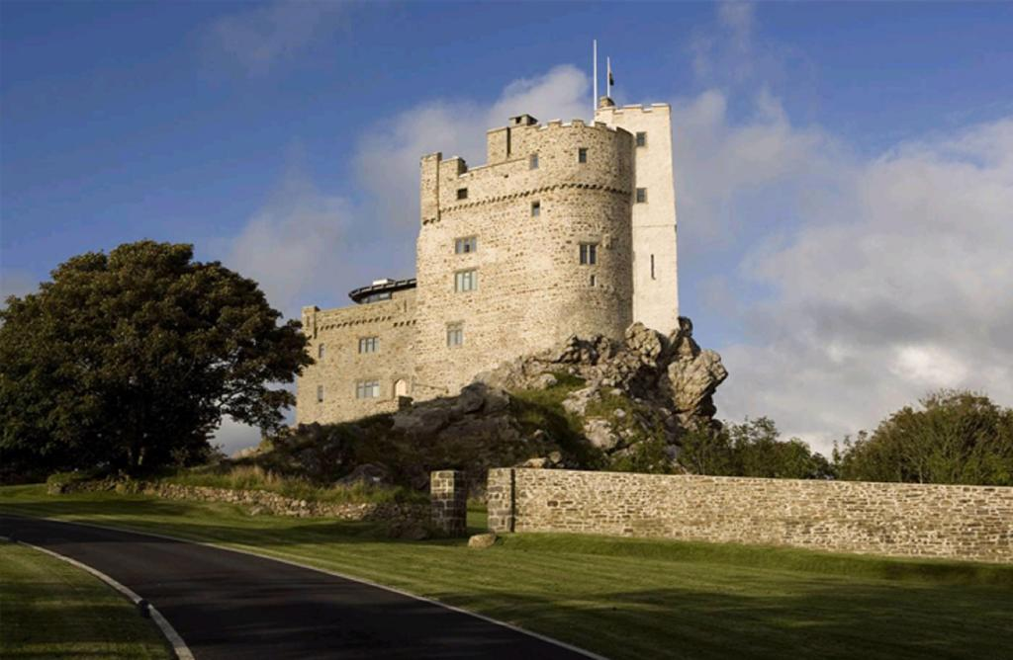
Roch Castle

After the De la Roches
After the departure of De la Roches from Great Nash and Llangwm, the manor fell into ruin. However later in the 15th century the estate was acquired by the Nash family who rebuilt the manor house. In the late 17th century, the house came into the possession of the Owen family through marriage. The Owen family of Orielton can trace their ancestry back to 12th century. The manor came into the hands of the Owen family around 1704 through the marriage of Dorothy Corbett, heiress to the Nash estate to the son of the 2nd baronet Sir Hugh Owen. He was Charles Owen who was born in 1684.
When the Civil War broke out the attitude of the Owen family in Pembrokeshire was indeterminate and non-committal. He would be a clever man who could say whether the first Sir Hugh Owen favoured the king or the Parliament. But there are two factors that might point Sir Hugh in either direction. He strongly supported the appointment of Arch Puritan the Rev Peregrine Phillips to the benefices of Langhum and Freystrop. Then there is the tunnel which supposedly runs from Mill Street, right beside St Jerome’s to Great Nash Farm. See below
When St. Jerome’s was being restored in 2016, the clearing of the floor space in the De la Roche Chapel revealed memorial plaques set into the floor in front of the effigies. They are dedicated to one Colonel Charles Owen of Great Nash who died in 1716. In his brief thirty years, Charles not only reached the rank of Colonel in the army, he was also the Mayor of Pembroke in 1714.

Peregrine Phillips (1623 – 1691)
Peregrine Phillips was the son of the vicar of Amroth. He attended the Puritan school of Stanley Gower at Brampton Bryan before going on to Oxford, but the Civil War broke out before he could proceed to graduation. The early records concerning him are scanty; the only references to him are that the authorities paid him £70 for preaching in 1650-1, and allowed him £5 for repairing the rectory at Llangwm. He later became minister of Llangwm and Freystrop. His fame as a preacher had spread and Oliver Cromwell requested him to preach before him and his officers during the siege of Pembroke in 1648, and again to pray on board every ship that sailed to Ireland out of Milford in 1649. After the Civil War and the Commonwealth, he refused to sign up to the 1662 Act of Uniformity and had to leave Llangwm and Freystrop; although there are stories of kindness and protection shown him by the Owen family of Orielton and Great Nash.In 1672 he received a licence under the temporary Indulgence of Charles II to preach at his own house in Haverfordwest. He also founded the Albany Chapel on St Thomas Green, Haverfordwest, thus becoming a founding member of the emerging non-conformist movement. He died on 17 September 1691.

The Tunnel.
So it seems that the Owens were strict Puritans too. Then how does one explain a tunnel that runs from Great Nash to Mill Street, located just outside the church? Archaeologists suggest that it is an ancient drain. But why didn’t they direct the drain straight down to the river, rather than direct it nearly a mile to the south and to Llangwm Church? Other theories suggest that it is a smugglers’ tunnel; after all the authorities did build a customs house down to the east at Black Tar.
The popular but still doubtful explanation is that it is a Catholic Priest’s escape hole that ran from the church to Great Nash. But how do they explain the presence of the strongly Puritan Peregrine Phillips residing at Llangwm’s Rectory and conducting worship at St. Jerome’s? He would never allow a Catholic Mass to be said in his church… But then, how on earth did the highly decorated covered Holy Water Niche in the De la Roche chapel survive that period? In any normal Puritan church, it would have been destroyed. On top of that the faces on the effigies were also left alone. Every single effigy in St. David’s Cathedral had its face removed, because it is idolatrous, but not here in Llangwm. Could it be that our Peregrine Phillips was secretly allowing the Catholic Mass to be said in the chapel for the local members of the Owen family? After all, his squire and benefactors may have been secret Catholics. We will never know.

We hope you’ve enjoyed this introduction to St. Jerome’s Church. Now if you have a Smart Phone or Tablet device, why not download the Talking Tapestry of Langum App and enjoy the full story of the 12th century Flemish settlement of Pembrokeshire and the founding of the De la Roche dynasty.

Welcome to St. Jerome’s is written by Heritage Llangwm
for the Friends of St. Jerome’s.

