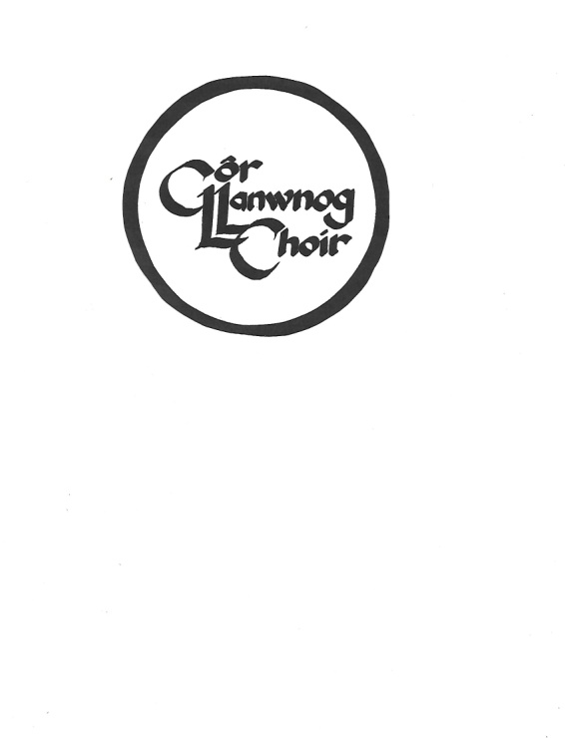
Rehearsals every Thursday, 7.30 pm,
Clatter Community Hall.
Contacts:
Conductor: Graham Marshman 01686 412442
Chair: Angela Swindell, 01686 413728
Vice Chair: John MacDonald, 01650 521304
Secretary: Wendy Wigley, 01686 440704

Concert Calendar:
Date Place Event

