HOPE MS Therapy Centre

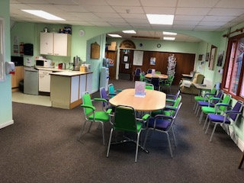

We are open on Mondays, Tuesdays and Wednesdays from 9 to 4.00 pm. We charge a modest annual membership fee and all our treatments are affordable.

We try hard to create an inviting, relaxed environment for all to meet. Our members their family and carers are always welcome.

**The HOPE Centre is all about and for its members**

Please do not hesitate to call us for a more in-depth explanation of our Oxygen Therapy as we strive to make this as bespoke as possible.

HOPE MS Therapy Centre

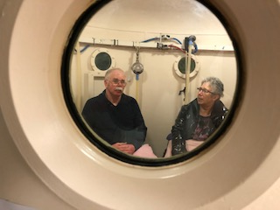

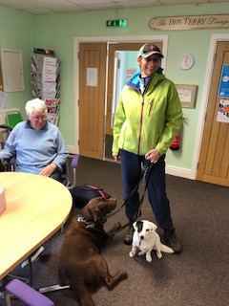

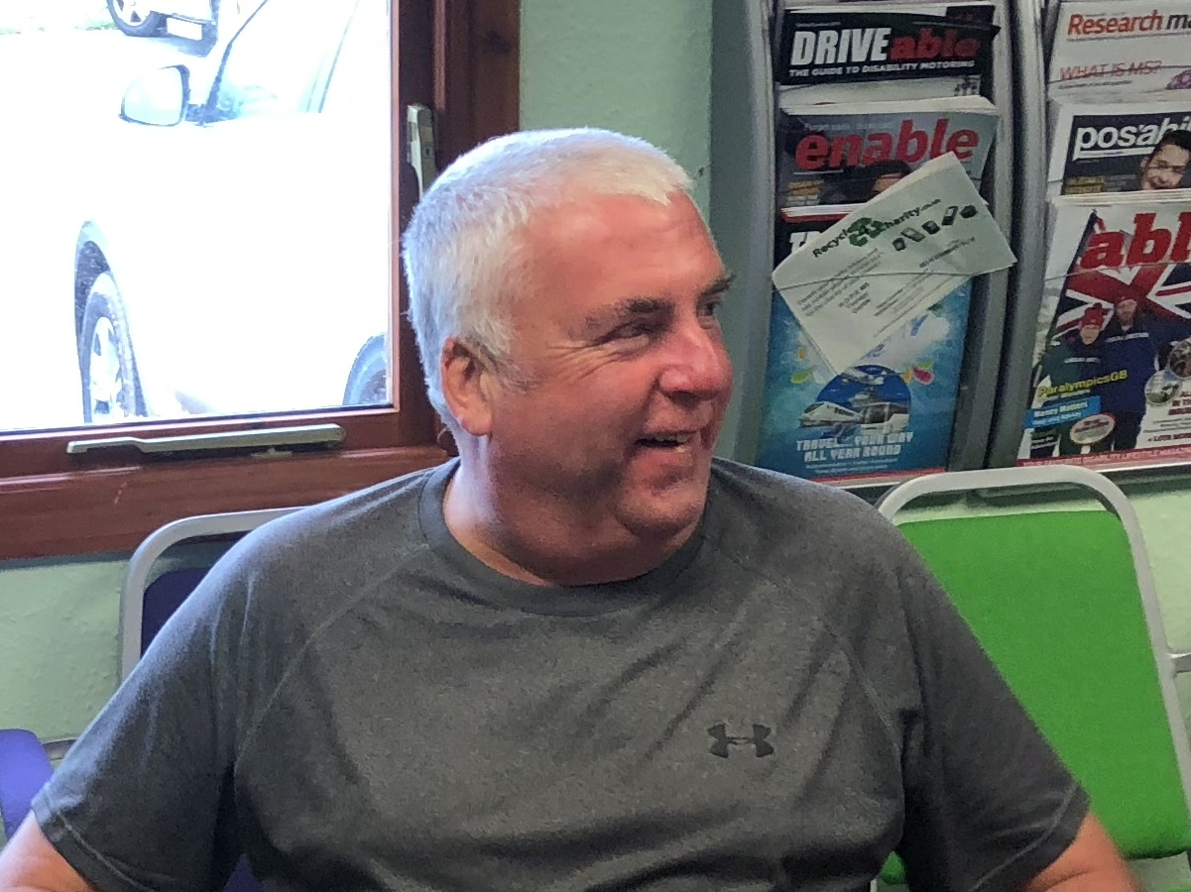

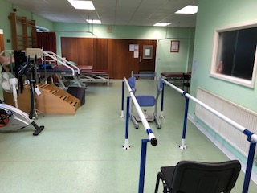

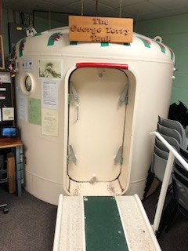

HOPE MS Therapy Centre

**What we do:** Provide accessible and affordable therapies to those affected by MS.

Make our services available to those with other conditions including Long Covid, Parkinsons Stroke, MND, Diabetic Ulcers, COPD, Cancer side effects, Fibromyalgia and many others. Please call us if you are unsure if we can help your specific condition.

**What we offer: Oxygen Therapy** – breathing oxygen in a pressurised chamber allows elevated levels of oxygen to be absorbed by the body into the bloodstream and tissues. This can help to relieve symptoms associated with a range of health conditions, improve circulation and reduce inflammation.

**Physical Therapy** – individual, tailored physio sessions using specialist equipment and expert guidance.

**Friendship**, support and advice to those living with a long-term condition. A place to come to meet up with friends as well as having therapy.

**Social** activities and opportunities for volunteering.

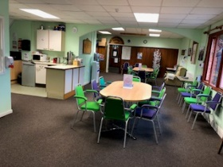  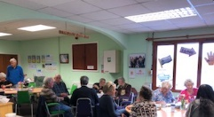



**“HOPE offers us continuous care”**

**“The physio services are first class”**

**“More regular than the NHS well worth paying for”.**

**All are welcome!**

**“Lovely to come to HOPE each week and see everyone”**

**Our Baro-Chamber**

**Our Physiotherapy Department**

**Through the porthole! Inside the Chamber**

FRIENDS

OF HOPE

Although we are a Charity set up primarily to support those affected

by MS we are not part of MS-UK or the MS Society.

Constant fund raising is challenging for any Charity and that is why we are so very lucky to have a fantastic network of people who kindly donate financially to HOPE on a regular basis.

We could not do what we do without their support and our donations go directly to benefitting users of our Centre by allowing us to offer our subsidised therapies.

We are also really grateful to our committed volunteers.

If you would like to support our Centre with a regular financial contribution, please fill in the donation form inside this leaflet and return it to the Centre. Also contact us if you would like to volunteer - we are a friendly bunch and would be very grateful for any help you could give.

**01646 600384**

HOPE MS Therapy

Centre



**Here to help**

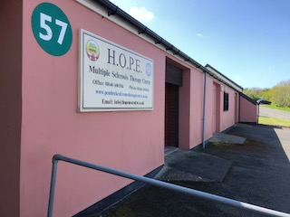

Charity No. 1126567

Company No. 06651359

**01646 600384**

[info@hopemscentre.co.uk](mailto:info@hopemscentre.co.uk) www.hopemscentre.co.uk

HOPE – Here to help

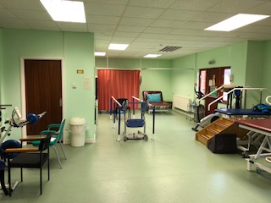 

Here to help you

Think differently

Think well

**HOPE MS Therapy Centre**

Unit 57 Honeyborough Business Park

NEYLAND, Pembs

SA73 1SE

**01646 600384** [**info@hopemscentre.co.uk**](mailto:info@hopemscentre.co.uk)

