Powys Befriending Service
Powys Befriending Service aims to improve the independence of people over 50 living in Powys, to maintain their social networks and remain in their own homes for as long as they are able. Clients may need support as a result of an illness, mental distress, disability, bereavement, retirement or having recently moved in to the area and having no social network.
Befrienders are volunteers who are subject to police checks, induction and ongoing training. They visit people in their own homes or in the community to provide companionship and support. They help promote personal choice, increase self – respect, support existing personal skills and the development of new opportunities.
Prior to the Covid outbreak we had a regular programme of groups and social activities throughout the county where people met to have coffees, teas and lunches, take part in arts and crafts, singing, board games, read and remember and a film club. We also had regular day trips during the summer months and around Christmas.
From March 2020 we had to quickly change the way we did things and offered our existing clients and new referrals telephone Befriending but quickly realised that was not suitable for everyone so developed other ways of supporting people via pen pals by post and email, a monthly newsletter and an online Coffee and Chat.
Online activity soon drew our attention to the fact that many people did not use computers or the internet and those that did lacked skills to do the things online they would like to. Funding for digital awareness was found to employ a Digital Support Officer, who recruited and trained new and existing volunteers to support people digitally. Current online activities include the ongoing coffee morning, Lunch Club at Home, Yarn & Yatter and Art & Crafts.
Post covid the plan is to have a blend of online activities, telephone Befriending, one to one support and live groups, to help build individuals' confidence to reconnect with their community and get out and about when it is safe to do so.
The need for our service has almost trebled over the past year and therefore our need for volunteers to support them – if anyone can spare an hour or two on a regular basis we would love to hear from them
Putting a Smile on Faces in Powys
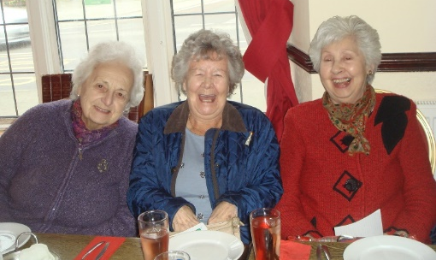
Lesley Austen
Cydlynydd Gwasanaeth Cyfeillio Powys
Powys Befriending Services Coordinator
01597 822191 pbs@pavo.org.uk https://www.facebook.com/powysbefriendingservice
PAVO, 30 Ddole Road Industrial Estate, Llandrindod Wells, Powys LD1 6DF
Registered Charity No. 1069557 a company limited by guarantee 3522144 Registered in Wales

